DWGTF Temporary Construction Project Sign – Trust Fund and DWSRF joint funding

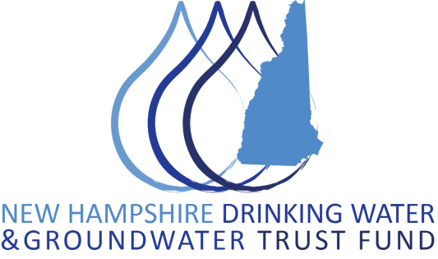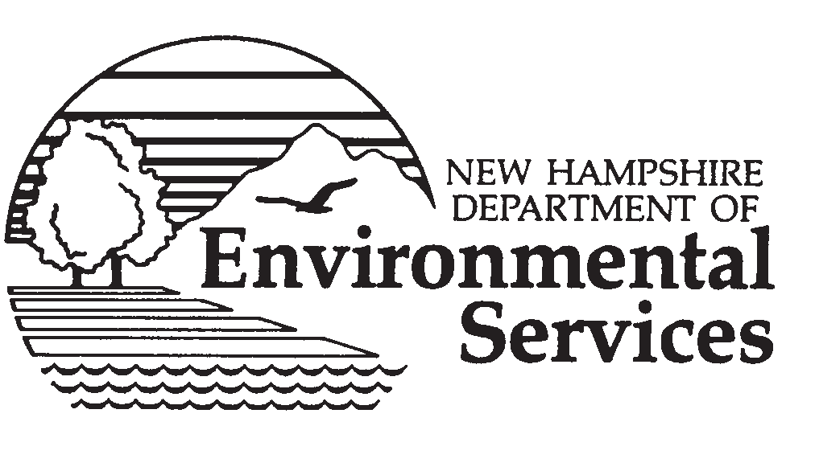

Black

**DWSRF PROJECT NUMBER: ________ DWGTF PROJECT NUMBER: DWGT-___**

**PROJECT NAME**

**Funds Provided by NHDES State Revolving Fund and NH Drinking Water & Groundwater Trust Fund**

Light Blue

#508AC8

Green

#0033CC

Blue

#1050B7

Dark Blue

#232E66

Med. Blue

#243B97

Blue

#3799FF

Blue

#000080

Yellow

#FFFF00

**WATER SUPPLY PROJECT**

PROVIDE 4” x 4” SIGN POSTS OR OTHER ADEQUATE SUPPORTS TO MOUNT SIGN AT APPROVED LOCATION

Green

#336633

Blue

#333399

Blue

#333399

4’-0” x 8’-0” x 3/4” HIGH DENSITY OVERLAY PLYWOOD SIGNBOARD OR OTHER APPROVED MATERIAL SUITABLE FOR SIGNS

Black

A

A